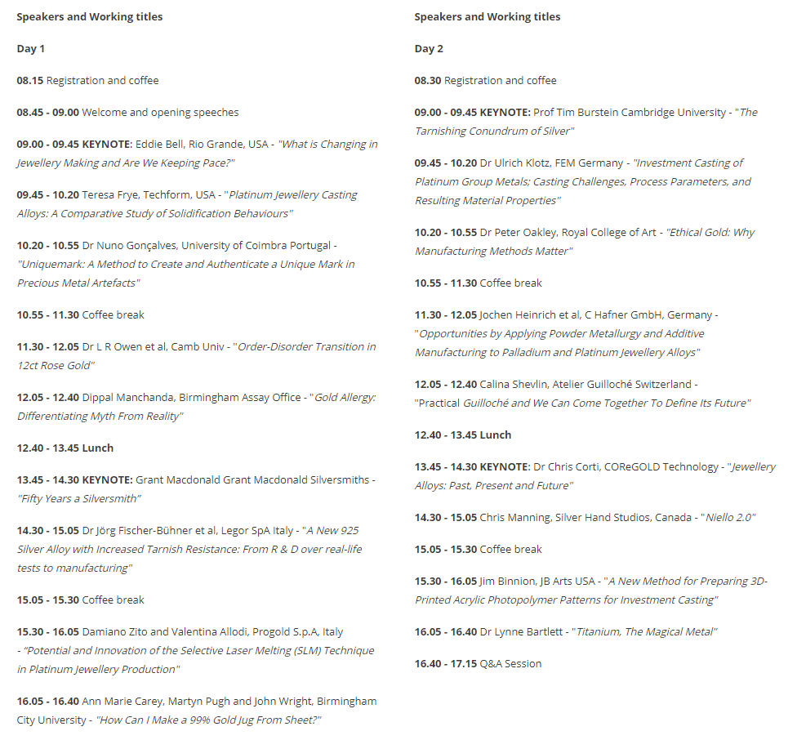

A close up of a sign

Description generated with very high confidence